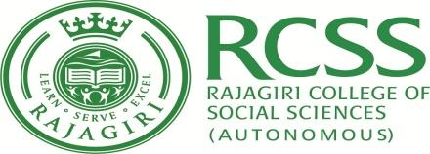

RAJAGIRI COLLEGE OF SOCIAL SCIENCES (AUTONOMOUS)
School of Commerce
BBA Semester – III CAE 2 September 2019
Time Table
Date | Subject | Venue | Time
September 16, 2019  Monday | Human Resource Management | Exam Hall | 9.00 – 10.30
 | Research Methodology |  | 1.30 – 3.00
September 17, 2019  Tuesday | Business Laws |  | 9.00 – 10.30
 | Marketing Management |  | 1.30 – 3.00

The students should report at the examination venue 15 minutes before the scheduled time.

Assistant Controller of Examination,
School of Commerce

