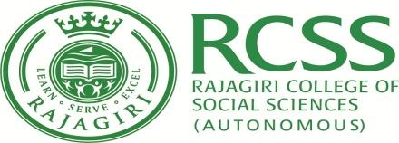

RAJAGIRI COLLEGE OF SOCIAL SCIENCES (AUTONOMOUS)
School of Commerce
B.Com Semester – III CAE 2 September 2019
Time Table
Date | Subject | Venue | Time
September 16, 2019  Monday | English : Gems of Imagination (Model I F&T/Computer application)  English Literature and/as Identity (Model II F&T) | Exam Hall | 9.00 – 10.30
 | Corporate Accounts I |  | 1.30 – 3.00
September 17, 2019  Tuesday | Financial Markets and Operations |  | 9.00 – 10.30
 | Quantitative Techniques for Business I (Model I F&T/Computer application)  Cost Accounting I (Model II F&T) |  | 1.30 – 3.00
September 18, 2019  Wednesday | Information Technology for Business(Theory)  (Model I-Computer application)  Goods and Services Tax (Model I and Model II F&T) |  | 9.00 – 10.30
 | Marketing Management |  | 1.30 – 3.00

The students should report at the examination venue 15 minutes before the scheduled time.

Assistant Controller of Examination,
School of Commerce

